Images of our 2019 June journey to The Hedges on Blue Mtn. Lake, NY

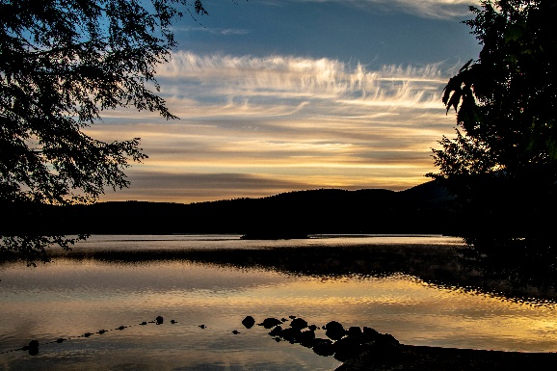

Since the summer of 1994, we have visited The Hedges annually on various dates and seasons. This trip to The Hedges on Blue Mountain Lake happened in June. The weather was excellent and we were fortunate enough to have all our kids and grandkids join us during some excellent weather and water time. We had a lot of outside activities and did manage a photo or two for our memories. The encounter with a lively beaver, an entertaining midnight electric storm, and a very active long weekend with our family are memories to share on the links below. Couldn’t be much better this year.

For the photos of our “solo” time at the Hedges, click [The Hedges: June 2019](https://photos.app.goo.gl/VMJ4uGXCHFyznyNE7).

For photos of all of us, click [The Hedges - Family: – June 2019](https://photos.app.goo.gl/Ut3jFbsbL8PkxC2D9).